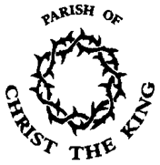
L

iving Hope

Our Advent Pilgrimage 2015.
Advent is the season leading up to Christmas, the goose is getting fat, and chestnuts will soon be roasting by an open fire.

But we often miss Advent’s power because December is full of pre-Christmas shopping and centres blasting out carols from mid-Autumn. Each year the busyness of this season serves to distract us from having an Advent that truly prepares us for the Holy Season of Christmas, with all its meaning.

Therefore let this Advent reflect a period of stillness, seeking and preparation amidst the craziness, let us be called to be a pilgrim people sharing in our sacred spaces, let us journey together across the Parish of Christ the King for Advent.

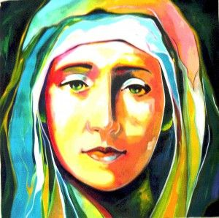
The Pilgrimage

This Advent season we have the chance to journey together across the Parish resting at each Church in turn, for meditation and prayer. This can be a simple way to enter into the Advent journey week by week in the midst of our busy everyday lives; a real chance to slow down and take time to unwind. Each of our Churches will provide a quiet, calm space to reflect and pray.

The Pilgrimage will be particularly focused on our senses, following the four themes of the Advent Season. We are invited into our sacred spaces to rest in the presence of God, to relax and draw on his strength and to listen to the stillness of God’s voice within us.

Let us please join together for this Advent Pilgrimage.

- Hope Monday 30th November 6.30-7.30pm Christ Church
- Faith Monday 07th December 6.30-7.30pm St Bartholomew’s Church
- Joy Monday 14th December 6.30-7.30pm St James’s Church
- Love Monday 21st December 6.30-7.30pm St Mary’s Church
Back by popular demand there will be hot chocolate with marshmallows and spiced mulled wine served after each gathering.

For more information please speak to Charlene.

