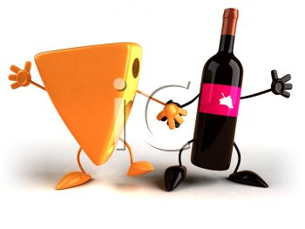

St Mary’s Wilshaw

Back by popular demand

Cheese & Wine evening

On: Friday the 9th October at: 7.30pm in the Sunday School   
Everyone welcome   
Lots of wine tasting and

'Call my Bluff'   
£3 on the evening includes all your wine!!

Please bring a lump of cheese to share