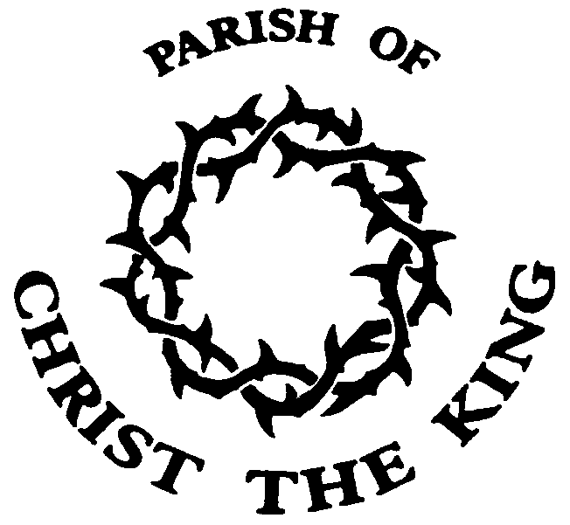
Meltham,
Christ the King
March 22nd 2020
MOTHERING SUNDAY

Opening prayers
We praise you Lord, for all those who have loved and laughed and laboured as they cared for their children.
Blessed be God for ever.
We praise you Lord, for all mothers who have wept in sorrow and in joy for their children.
Blessed be God for ever.
We praise you Lord, for Jesus, born to Mary his mother who, nurtured him in her love.
Blessed be God for ever.

Asking for forgiveness
Let us call to mind our sin, our failure to value the love of others and our failure to love as Jesus taught us to love.
For the times we hurt those who love us;
Lord we are sorry.
For the unkind thoughts we have;
Lord we are sorry.
For the unkind things we do;
Lord we are sorry.
For the unkind things we say;
Lord we are sorry.
If you are sorry, God forgives you.
May the God of love bring us back to himself, forgive us our sins, and assure us of his everlasting love, in Jesus Christ our Lord. Amen.

Reading
Near the cross of Jesus stood his mother, his mother’s sister, Mary the wife of Clopas, and Mary Magdalene. When Jesus saw his mother there, and the disciple whom he loved standing nearby, he said to her, “Woman, here is your son,” and to the disciple, “Here is your mother.” From that time on, this disciple took her into his home.
John 19:25-27 (NIV)

Sermon Summary
Mary, Jesus’s mother, had cared for him, nurtured him, and loved him throughout his entire life. Now, as he hung dying and in pain, his thoughts were not for himself. He knew that the resurrection was coming, he knew that he would always be there for all those he loved, and yet things would be different and no one except God understood how.
So, just as Jesus’s thoughts were for his Mother, and for all those he loved. Surely this Mothers Day our thoughts should not be for ourselves but instead they should turn to what we might do for others, especially our Mothers and those we love.

Affirmation of faith (the creed)
We believe in God the Father,
from whom every family
in heaven and on earth is named.
We believe in God the Son,
who lives in our hearts through faith,
and fills us with his love.
We believe in God the Holy Spirit,
who strengthens us
with power from on high.
We believe in one God;
Father, Son and Holy Spirit.
Amen.

Prayers of intercession

At this time of uncertainty, please pray for;

Our Churches
That we will be guided and inspired by the Holy Spirit
as we look to minister and worship in new ways.
Our nation
For our leaders, the National Health Service, the schools and children, and for those working to maintain supplies in our shops.
We pray that that there will be a calming of minds and hearts.
Our world
For greater co-operation between nations
Our Parish
That the whole community will come together to work through the challenges that we face.
We ask God to comfort those who are unwell or grieving.

The Lord’s prayer
As our saviour has taught us, so we pray:
Our Father in heaven, hallowed be your name,
your kingdom come, your will be done,
on earth as in heaven.
Give us today our daily bread.
Forgive us our sins
as we forgive those who sin against us.
Lead us not into temptation
but deliver us from evil.
For the kingdom, the power, and the glory are yours
now and for ever. Amen.
The Peace
Through the prophet Isaiah, God says, “as a mother comforts her child, so I will comfort you”.
The peace of the Lord be always with you.

We pray for Mothers and all who love us
For our mothers who gave us birth
We thank you Father
For all who feed and nourish us
We thank you Father
For all who comfort us when we are sad
We thank you Father
For all who teach us how to live
We thank you Father
For all who help us when we are lost in life
We thank you Father

Blessing
May you know the love of the God who gave birth to all of creation,
the God who’s love never ends. And the blessing of God Almighty, Father, Son, and Holy Spirit, be upon you and remain upon you always.
Amen.

